Pokhara University

Level: Bachelor | Semester – Fall | Year : 2009
Programme: BE |  | Full Marks : 100
Course: Electronic Circuits |  | Time : 3hrs.

Candidates are required to give their answers in their own words as far as practicable.
The figures in the margin indicate full marks.

Attempt all the questions.

1. | - Why Common Collector configuration amplifier is also called emitter follower? Verify your answer with the help of circuit diagram and necessary derivation.  - for the given circuit find out:  - Overall voltage gain (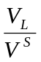)  - AC output voltage if V_{s} = 1mVp-p  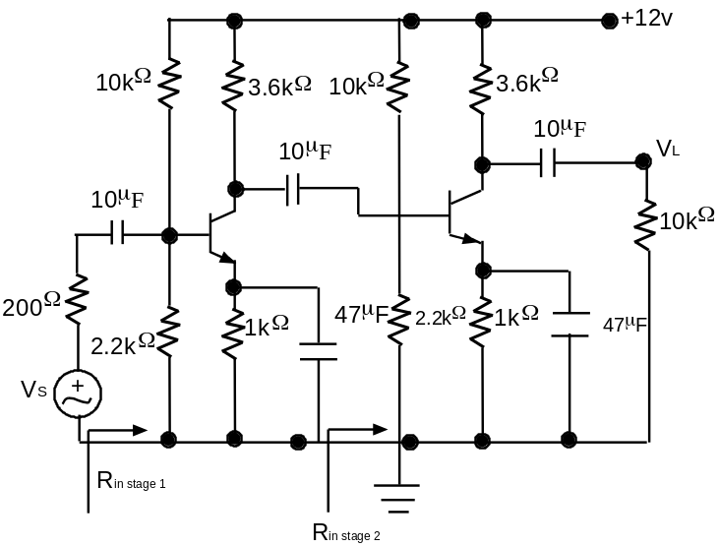 | 7  8
2. | - What is efficiency? Derive the expression of the efficiency of direct coupled load class A amplifier.  - “At higher frequencies, the gain of one amplifier reduces.” Do you agree or disagree with this statement? Justify your answer.  - Explain the effect of an Emitter Bypass Capacitor on low frequency response with necessary circuit diagram. | 5  5  5
3. | - Draw circuit diagram for complementary symmetry push-pull Class B amplifier. Explain its working principle. Discuss its advantages and disadvantages.  - "Negative feedback reduces the voltage gain, but provides better stability." Verify it. What is the effect of negative feedback on bandwidth, signal to noise ratio, input/output impedances? (no derivations are required.)  - Derive the expression of input impedance of the current series negative feedback configuration. | 5  5  5
4. | - What ate the Barkhausen criteria for oscillation? Using these conditions, derive the expression of frequency of oscillation for Wein Bridge oscillator.  - With the help of necessary circuit diagrams and derivations, discuss the applications of an OP-Amp as a summer and Integrator. | 8  7
5. | - Briefly discuss the following parameters: voltage gain, input impedance, output impedance, CMRR and Bandwidth of ideal as well as non ideal Op-Amp.  - Draw the basic circuit of log amplifier, and derive the expression for output voltage of this circuit. What are its drawbacks? How these drawbacks can be minimized? Explain. | 7  8
6. | - What is the basic principle of A/D converter? Explain the Dual slope A/D converter.  - What do you mean by Regulated Power supplies? Draw Transistor Series regulator circuit and explain its operation. | 8  7
7. | Write short notes on (Any Two)  - The collpit Oscillator  - Schmitt Trigger  - R-2R Ladder D/A Converter | 5×2

